PPPoE Connection-10 Aug 2025

PPPoE : User : vibol ; password: vibol

Think:

1. After we have user and pass we need to find where to can connect and port input from ISP.
2. After we can connect to ISP where we can deliver the DHCP to the client
3. Which port do we want to do dhcp server
4. After providing dhcp server we need to configure NAT to make the client also can use internet
5. Think about bridge port: Group Port in our MIK together.

Step by Step:

1. Connect PPPoE : note on running and status connected

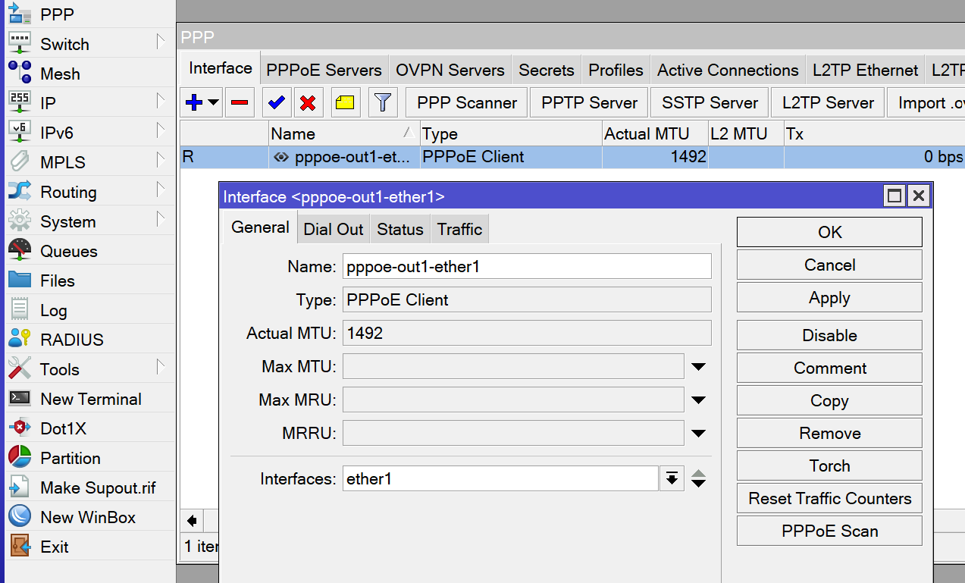

1. Create Bridge

1. Select port to our bridge

1. Create IP address: to provide to client

1. Configure: DNS

1. Create DHCP Server

1. Configure NAT : do ipconfig /release renew

